[PPJP-5] Checking the visuality of "Dog Grooming" part Created: 21/Aug/24 Updated: 28/Aug/24
Status: | To Do
Project: | Paws Paradise-Jira project

Type: | Bug | Priority: | Medium
Reporter: | Tomer Darmon | Assignee: | Unassigned
Environment: | Google Chrome  Version 124.0.6367.202 (Official version) (64 bit)  Microsoft Edge  Version 124.0.2478.97 (Official build) (64-bit)

  Attachments: | 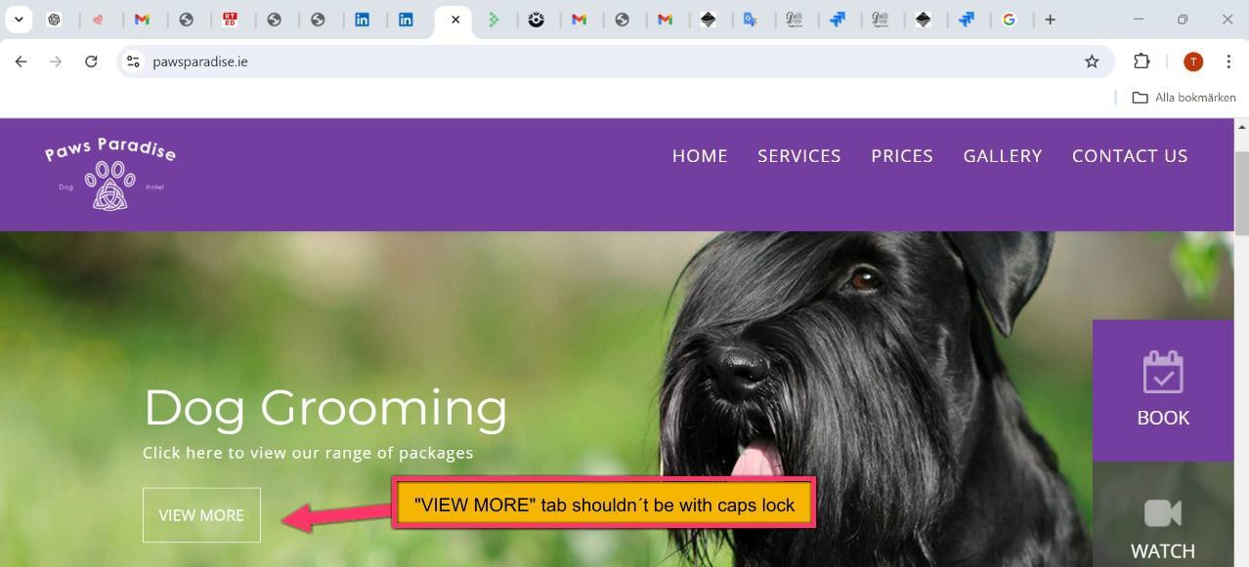
Severity1: | S5-Low

Description
Steps to Reproduce :
- Enter the website: https://www.pawsparadise.ie/
- Check the font size and style if it matches the other fonts of the previous tabs of "Doggie Paradise" and "Jump for Joy"
Actual Result :
The tab "VIEW MORE" in the "Dog Grooming" section was supposed to be written without caps lock
Expected Result :
I will expect that the font style and size will be the same as at the other tabs and everything is clear and understood

24

